Decoding Discount Preferences in the Apparel Industry: A Conjoint – SEM – Logistic Regression Framework
(A001 - Deepasha Kapadia, A007 - Grishma Mehta, A012 - Ishita Pednekar, A051 - Shreeya Thomas, A061 - Abhishek Barve)
Mentored by: Dr. Rushina Singhi
Department of Statistics, School of Mathematics, Applied Statistics Analytics, SVKM’s NMIMS (Deemed-to-be University), Mumbai, India

Abstract:
The efficacy of discount coupons in the competitive apparel retail sector is often undermined by a reliance on generic, one-size-fits-all promotional strategies. To address this, we propose and validate a novel integrated analytical framework that synergistically combines Conjoint Analysis, Structural Equation Modelling (SEM), K-means Clustering, and Logistic Regression. This multi-method approach moves beyond superficial preference measurement to deliver a holistic understanding of consumer behaviour, linking stated preferences to underlying psychological drivers, segmenting the market accordingly, and ultimately predicting purchase likelihood.

Primary data was collected from 253 respondents via a structured survey designed to capture discount attribute preferences, psychological constructs based on the Theory of Planned Behaviour (TPB), and behavioural intentions. The analysis commenced with Conjoint Analysis, which quantified the relative importance of key discount attributes, revealing that Minimum Spend (27.66%), Discount Type (26.92%), and Expiry (26.00%) are paramount in shaping consumer utility, with a clear preference for deeper percentage discounts. Subsequently, an SEM model, grounded in the TPB, was developed to uncover the psychological mechanisms driving coupon usage. The model demonstrated a good fit (CFI=0.922, RMSEA=0.080) and identified Perceived Behavioural Control (β=0.657, p<0.001) and Subjective Norms (β=0.425, p<0.001) as the most significant direct antecedents of behavioural intention, which itself was a powerful predictor of actual behaviour.

The latent scores from the SEM and the utilities from the Conjoint Analysis were then integrated as inputs for K-means clustering, yielding three distinct and actionable consumer segments: "Deal-Hunters" (highly promotion-responsive), "Balanced Pragmatists" (moderate, value-driven), and "Hard-to-Please Skeptics" (low engagement with standard offers). Finally, a Logistic Regression model incorporating segment membership, psychological scores, and preference utilities was built to predict purchase behaviour. The model exhibited strong predictive power, achieving 89.5% accuracy, with Subjective Norms and specific psychographic traits emerging as the most influential predictors.

This research makes significant theoretical and practical contributions. Theoretically, it demonstrates the efficacy of a sequential, multi-method framework for modelling complex consumer decision making. In practice, it provides marketers with a robust, data-driven methodology for moving beyond demographic segmentation to identify psychologically-defined consumer profiles. This allows for the creation of highly targeted discount strategies and precise conversion probability forecasting to maximize marketing return on investment.

- Introduction:
Today’s modern apparel industry is defined by intense rivalry, quick evolving fashion trends, and more discriminating consumers. In this saturated market, discount coupons have emerged as a pivotal marketing tool to drive sales, enhance customer loyalty, and clear inventory. It is common for any consumer to be attracted more towards the offer that satisfies his utility the most, and also benefits him to a larger extent. Consumers perceive and value various aspects of a discount coupon differently—such as percentage discount types (e.g., percentage-off vs. cashback), validity period, and minimum purchase requirement.
Instead of the traditional one-size-fits all approach, a shift towards a more consumer focused personalization with respect to the discounts offered to them is observed among marketers which necessitates the need for a deeper, more nuanced understanding of consumer decision-making process. This research project aims to capture not only the consumer preferences superficially but also dive deeper into the psychological and behavioural aspects that play a role in the consumers decision making, with respect to their discount coupon preferences.

The study of consumer choice and purchasing behaviour necessitates an integrated methodological approach that moves beyond aggregate data analysis to capture preference heterogeneity and the complex psychological factors influencing decision-making. The proposed methodology begins with Conjoint Analysis (CA) to determine customer preferences for multi-attribute products or services. This technique is recognized as the leading tool for measuring consumer preferences and is crucial in New Product Development (NPD). For instance, Wang & Wu (2014) successfully combined CA with the Kano Model to extract customer utilities and classify attribute perceptions for smartphone optimization. Similarly, Head & Ziolkowski (2012) used CA to gain insights into how young adults value various mobile phone features. This step acknowledges the constraint identified by De Bruyn et al. (2008) that traditional CA usually requires "considerable customer input". By focusing CA solely on specific discount attributes (e.g., percentage, expiry, minimum value), the current research leverages CA's preference models while adopting an efficient input strategy, addressing the challenge of designing effective decision aids with minimal customer input.
The second stage of this framework utilizes Structural Equation Modelling (SEM), leveraging the Theory of Planned Behaviour (TPB), to understand the psychological factors that drive the preference for a particular discount coupon. This approach directly addresses the primary conceptual gap identified in adoption research: the reliance on a "one-size fits all" adoption model, which may be misleading across diverse consumer populations. Head & Ziolkowski (2012) demonstrated the necessity of this step by using SEM (PLS analysis) to investigate how antecedents to attitude (such as Perceived Expressiveness and Perceived Enjoyment, stemming from models like TAM and Nysveen et al.) differed significantly across customer segments. By employing the extended TPB model, incorporating variables such as impulsiveness, value consciousness, and trust, this research fulfils the need to move beyond standard utilitarian and hedonic motives to capture a richer set of psychological drivers. This enhanced causal model then feeds directly into the subsequent segmentation phase, linking the objectively measured utilities (CA) with the underlying subjective drivers (SEM).
The integration of preference data and psychological drivers sets the stage for Behavioural Segmentation through Clustering. Past research frequently employs clustering, such as K-means, on preference data derived from CA outputs to identify homogenous preference segments. However, traditional segmentation methods face several limitations. Wang & Wu (2014) noted that their study neglected to include consumer demographic variables in market partitioning, while John et al. (2023) highlighted that simple transactional models like the RFM framework suffer from an inability to reflect differences between the consumption and behaviour of customers. Furthermore, Vrhovac et al. (2024) and Ufeli et al. (2025) emphasized the inherent methodological difficulty of clustering complex, mixed-type datasets containing both numerical and categorical variables, which often leads to suboptimal results. By using the articulated utilities (CA) and psychological factors (SEM) as segmentation bases, this research avoids the deficiencies of relying on demographic data alone and compensates for the simplified view provided by transactional models. The approach relies on an implicit segmentation based on preference and motivation, aiming to create more actionable, behaviourally relevant segments that reflect genuine differences in consumption patterns.
Finally, the resultant segment profiles and measured preferences are utilized in Purchase Prediction via Logistic Regression. Logistic Regression is a well-established technique used to investigate the joint effects of consumer and coupon characteristics on redemption. Chakraborty & Cole (1991) confirmed that consumer characteristics such as deal proneness and behavioural loyalty are the most important predictors of coupon usage. Critically, modelling consumer response to promotions introduces a severe methodological concern: self-selection bias due to non-random missing data. To overcome this, Chakraborty & Cole (1991) employed a sophisticated two-stage estimation procedure (Heckman/Maddala) when modelling repurchase behaviour. This framework acknowledges the methodological imperative to use techniques that account for non-randomness when predicting behaviour. Furthermore, the prediction step must address the contemporary research gap identified by Langen & Huber (2023), who note that the field is shifting from predictive Machine Learning (ML) approaches to Causal ML algorithms (such as Causal Forests) that can isolate the causal effect of marketing interventions. The current framework fulfils the preparatory requirement for Causal ML by providing highly granular, preference-based customer profiles, positioning the research at the frontier of causal analysis and policy optimization.
The rationale of this project stems from the critical need to move beyond the isolated analytical methods. Our research offers a fragmented view of consumer behaviour, by integrating Conjoint Analysis, Structural Equation Modelling (SEM) based on the Theory of Planned Behaviour, Clustering, and Logistic Regression into a single, cohesive framework. This approach directly addresses the gap in literature that the analytical methods used in this research have not been used in this particular framework combination before, and this framework helps us dive deeper to analyse the psychological and behavioural aspects of consumer behaviour rather than just the superficial consumer choice that affects the consumer preferences with respect to discount coupons in the apparel industry. For example, while Conjoint Analysis (CA) and the Theory of Planned Behaviour (TPB) are established methods, they are often employed in isolation. Head, M., & Ziolkowski, N. (2012) used Conjoint Analysis, Cluster Analysis and SEM together to understand student attitudes of mobile phone features. Chakraborty, G., & Cole, C. (1991) used Logistic regression to investigate the joining effects of consumer and coupon characteristics on redemption. Sentosa, I., & Mat, N. K. N. (2012) employed SEM to examine the Theory of Planned Behaviour (TPB) and Technology Acceptance Model (TAM) in internet purchasing.
This study goes beyond conventional surface-level standards by utilizing a multi-method framework that connects preference measurement (CA), psychological modelling (SEM-TPB), behavioural segmentation (K-means), and purchase prediction (Logistic Regression). This framework demonstrates how these methodologies can be synergistically combined to move from measuring surface-level preferences to explaining their psychological roots, grouping consumers accordingly, and ultimately forecasting behaviour.

2. Data Description:
Data Source:
The primary data used in this study was collected through a survey conducted using a structured questionnaire titled “Designing the Right Deal” distributed via a Google Form.
The questionnaire was designed to capture a comprehensive view of consumer behaviour, encompassing demographics, shopping habits, psychological drivers, social influence, and specific preferences regarding discount structures. A total of 253 valid responses were recorded from participants belonging to different demographic backgrounds.
The dataset consists of 76 variables. It includes demographic variables, behavioural constructs, coupon framing scenarios, and attitudinal measures. The data was captured mainly on a 7-point Likert scale as well as a few categorical variables. Each row represents an individual consumer. Broadly, the survey was classified in 7 sections.

Survey Section | Variable Crux | Types of questions asked
1 | Description of the Survey
2 | Demographics | Age, Gender, Education, Employment Status, Monthly Household Income, Location.
3 | Shopping Behaviour | Shopping Frequency, Consumer Expenditure, Consumer behaviour across coupon awareness, redemption, sensitivity to savings, threshold spend, Preferred discount type and app for shopping.
4 | Scenario Based Questions | 8 Scenarios capturing different offer combinations of Discount Type, Minimum Spend Limit in the offer, Expiry of discounts, and Redemption method to identify how likely a consumer would purchase given a respective scenario.
5 | Personality Traits | Various statements to capture a consumers’ Impulsiveness, Fear of Missing Out tendency, Value Consciousness, Trust, Attitude towards using discounts, Subjective Norms, Self-Efficacy about using discounts, Behavioural Intention to use, Actual use of discounts.
6 | Psychological Behaviour | Questions to capture the psychology and emotions of consumers while using discounts.
7 | Purchase Behaviour | Assuming that the consumer is offered their most preferred discount, whether they would make a purchase.

The study utilized multiple interconnected datasets derived from the same base survey (DDA dataset) to examine consumer behaviour and decision-making toward discount offers. Each analytical technique—Conjoint Analysis, Structural Equation Modelling (SEM), Clustering, and Logistic Regression—used specific subsets or transformations of this data. The datasets and their respective variables are described below. We renamed all the 76 columns of our dataset for our convenience. (refer to Appendix)
The Conjoint dataset aimed to identify consumer preferences for various discount configurations by simulating eight purchase scenarios. Each respondent evaluated multiple discount offers that varied systematically across key attributes.
Dataset Details:
- Number of respondents: 253
- Columns: Scenario, Discount Type, Minimum Spend, Expiry, Redemption Method, and Rating (likelihood to purchase).
Attributes and Levels:
Attribute | Levels / Examples
Discount Type | 20% Off, ₹500 Flat Off, Buy 1 Get 1 Free, Cashback, Free Shipping.
Minimum Spend | None, ₹500, ₹1000, ₹2000, ₹3000
Expiry | Valid Today Only, 3 Days, 7 Days, 14 Days
Redemption Method | Automatic at Checkout, Code at Checkout, Wallet Credit
Rating | 7-point Likert scale (1 = Very Unlikely to 7 = Very Likely)
This dataset was analyzed using Conjoint Analysis to estimate part-worth utilities and attribute importances, representing how each discount feature influences consumer purchase intention.
The SEM dataset focused on examining psychological determinants of discount usage, following the Theory of Planned Behaviour (TPB) framework.
Latent Constructs and Items:
Construct | No. of Items | Example Items
Attitude (ATT) | 5 | “Using discounts is a smart way to shop.”
Subjective Norms (SN) | 4 | “People who are important to me think I should use discounts.”
Perceived Behavioural Control (PBC) | 4 | “I find it easy to locate and use valid discounts.”
Behavioural Intention (INT) | 3 | “I intend to use discounts/coupons the next time I shop.”
Behaviour (BEH) | 3 | “In the past month, how often did you use a discount or coupon?”
Measurement Scale:
All items were measured using a 7-point Likert scale (1 = Strongly Disagree to 7 = Strongly Agree), except for frequency/proportion-based behavioural items that were ordinal.
This dataset was analysed using Exploratory Factor Analysis (EFA) and SEM to validate construct relationships and assess the predictive influence of ATT, SN, and PBC on INT and BEH.

The Clustering dataset was developed to segment consumers based on their psychological and behavioural tendencies.
It integrated three key components:
Psychographic variables (from the original survey) capturing shopping motivations and emotional drivers
SEM construct scores (ATT, SN, PBC, INT, BEH), and
Conjoint-derived attribute importances, representing the relative importance consumers assign to different discount features.
Psychographic Statements Included:
- “Shopping is a way for me to reward myself.”
- “I like being the first among my peers to try new offers.”
- “I enjoy talking about discounts I got with others.”
- “I prefer quality over discounts, even if it costs more.”
Each statement was measured on a 7-point agreement scale.
The clustering analysis aimed to identify distinct consumer segments (e.g., deal-seekers, quality-focused shoppers, impulsive buyers) using K-means, followed by ANOVA tests to validate cluster separation across SEM and conjoint dimensions.
The Logistic dataset was designed to predict the likelihood of a consumer making a purchase based on their psychological traits, conjoint preferences, and cluster membership.
Integrated Predictors:
- Logistic module variables (from original data): purchase intention, satisfaction, comprehension, redemption method, etc.
- SEM scores: latent factor scores for ATT, SN, PBC, INT, BEH.
- Conjoint importances: weights reflecting individual discount attribute preferences.
- Cluster labels: consumer segments identified from the clustering stage.
Key Variables:
Variable | Description
E2 (Target) | “Would you buy now with this offer?” (Binary: 1 = Yes, 0 = No)
E3 | Likelihood to purchase (1–7 scale)
E5 | Satisfaction with the offer (1–7 scale)
E6 | Comprehension of offer (1–7 scale)
E7 | Redemption method recalled (categorical check)
The logistic regression model used these variables to estimate the probability of purchase and to identify which factors (e.g., positive attitude, ease of use, cluster membership) most significantly influenced the buying decision.

3. Methodology:
This study adopts an integrated, multi-stage analytical framework to comprehensively model and predict consumer purchase behaviour in response to online discount coupons. This approach moves beyond simple preference ranking or psychological modelling alone, integrating quantitative preference elicitation, a theoretical behavioural model, customer segmentation, and predictive analytics.

Step 1: Conjoint Analysis – Identifying Discount Preferences

Objective
The primary objective of this stage is to quantify the relative utility and importance of discrete discount-related attributes in driving consumer preferences during the online purchasing process.

Procedure and Rationale
Discount offerings are inherently multidimensional, taking into account variables like the size of the discount (e.g., percentage), conditional effort (e.g., minimum order value), temporal pressure (e.g., coupon expiration), and reward type (e.g., cashback vs. flat discount). Conjoint Analysis (CA), which estimates the part-worth utility given by each attribute level, offers a reliable way to break down consumer decision-making.
- Design: A fractional factorial design was employed to generate a manageable and statistically efficient set of hypothetical discount scenarios (stimuli) presented to the respondents.
- Data Collection: Respondents were asked to rate these scenarios based on their overall purchase preference or likelihood.
- Estimation: A part-worth utility model was estimated using Ordinary Least Squares (OLS)
- Output: The relative importance of each discount attribute was calculated based on the range of its estimated part-worth utilities, identifying the most influential discount features.

Connection to Subsequent Steps
The preference profiles derived from conjoint analysis serve as the core behavioural stimulus. Specifically, the estimated utilities inform the psychological drivers in the subsequent SEM stage by establishing which objective discount configurations hold the highest subjective value for the consumer, thereby acting as a powerful antecedent in the behavioural modelling phase.

Step 2: Structural Equation Modelling (SEM) – Understanding Psychological Drivers

Objective
This stage aims to examine the relationships between key psychological constructs and how they influence consumers’ intentions and actual behaviours related to the use of discount coupons, based on the Theory of Planned Behaviour (TPB) framework.

Model Structure and Rationale
While the conjoint analysis identified what consumers prefer, the SEM approach explains why they act on those preferences. The model is grounded in the core components of TPB, which capture consumers’ cognitive and motivational processes toward discount redemption:
- Attitude (ATT): The consumer’s overall positive or negative evaluation of using discount coupons.
- Subjective Norm (SN): The perceived social influence from peers or significant others encouraging coupon usage.
- Perceived Behavioural Control (PBC): The perceived ease or difficulty in finding, accessing, and redeeming discounts.
- Behavioural Intention (INT): The consumer’s self-reported likelihood or plan to use a discount coupon.
- Actual Behaviour (BEH): The consumer’s recent or stated coupon redemption activity.

Analytical Approach
A Confirmatory Factor Analysis (CFA) was first conducted to validate the measurement model, confirming the reliability and validity of all constructs.
The structural model then examined the directional relationships among these variables:
PBC → INT (β = 0.657, p < 0.001): Consumers who perceive higher control or ease in redeeming discounts show stronger purchase intentions.
SN → INT (β = 0.425, p < 0.001): Social influence significantly shapes consumers’ intentions, reflecting the importance of peer and societal approval.
ATT → INT: A positive but comparatively weaker effect, suggesting that while attitudes matter, they are secondary to perceived control and social norms.
INT → BEH (β = 0.974, p < 0.001): Behavioural intention has the strongest and most direct influence on actual purchase behaviour, confirming the TPB framework.
- Structural Model Estimation: The SEM results confirm that Perceived Behavioural Control (PBC) and Behavioural Intention (INT) are the strongest direct predictors of actual behaviour. Subjective Norm (SN) also plays a major role by influencing consumers’ intentions, emphasizing the importance of social validation in online purchase decisions.
Overall, the model successfully captures how consumers’ perceptions of control, social influence, and intention interact to drive discount redemption behaviour.
- Model Fit: The model demonstrated acceptable goodness-of-fit values:
- Comparative Fit Index (CFI ≥ 0.90)
- Tucker-Lewis Index (TLI ≥ 0.90)
- Root Mean Square Error of Approximation (RMSEA ≤ 0.08)
- Standardized Root Mean Square Residual (SRMR ≤ 0.08)
These indices confirm that the TPB-based model fits the data well and provides a valid representation of the psychological mechanisms underlying consumer coupon behaviour.

Connection to Subsequent Steps
The output from the SEM—specifically the standardized latent factor scores for Attitude, Subjective Norm, PBC, Intention, etc.—are extracted and utilized as sophisticated, continuous behavioural variables for the next segmentation stage.

Step 3: Clustering – Behavioural Segmentation

Objective
The goal of this stage is to classify the heterogeneous consumer base into distinct, homogeneous groups based on their discount preferences (Conjoint utilities) and their underlying psychological drivers (SEM factor scores).

Procedure and Rationale
Segmentation is crucial, as consumers' responses to discounts are diverse, motivated by varying degrees of perceived savings, social influence, or spontaneity. Clustering allows for the differentiation of target audiences. The following were included in the merged dataset for clustering:

Data Input: Importance of discount types developed from conjoint analysis. All latent psychological constructs (ATT, SN, PBC, Intention, Impulsiveness, etc.) have factor scores obtained from SEM.

Approach: To find naturally occurring clusters, the standardised input variables were subjected to K-means clustering.

Validation: The elbow approach was used to calculate the ideal number of clusters, which was then confirmed by the silhouette coefficient. One-way Analysis of Variance (ANOVA) on the cluster means for each input variable was used to further validate cluster distinction.

Connection to Subsequent Steps
The Cluster Membership variable (a categorical identifier) created in this step acts as a powerful, integrated predictor that summarises a consumer's entire preference-and-psychology profile for the final predictive model.

Step 4: Logistic Regression – Predicting Purchase Likelihood

Objective

The final stage utilises logistic regression to estimate the likelihood of a consumer making a purchase, based on their underlying psychological profile, preferred discount attributes, and assigned behavioural segment.

Model Specification and Rationale
This predictive model provides the most actionable insight by quantifying the likelihood of conversion i.e. if the consumer purchases or not. The dependent variable is a Binary Purchase Outcome (Y=1 for purchase, Y=0 for non-purchase).
The model specification is:
Purchase Probability:
Independent Variables include:
- Cluster Membership: The categorical variable resulting from the $\text{K}$-Means analysis.
- SEM Factor Scores: Continuous factor scores (e.g., ATT, PBC, BI).
- Conjoint Utilities: Continuous utilities for the most critical discount attributes.

Model Evaluation and Insights
The model achieved strong predictive performance with the following results:
- Accuracy: 89.47%
- F1 Score: 0.94
- Precision (Positive Class): 91%
- Recall (Positive Class): 97%
This indicates that the model performs well in correctly identifying users who are likely to make a purchase, with minimal misclassification errors

Integration and Research Contribution
The synergistic combination of these analytical techniques yields comprehensive insights:
- Conjoint: Defines the optimal discount product ("At what discount will they buy?").
- SEM: Explains the underlying motivation ("Why are they compelled to buy?").
- Clustering: Identifies actionable groups ("Who is the target audience?").
- Logistic Regression: Provides predictive power ("What is the probability they will buy?").
This integrated framework significantly advances our understanding of how consumers react to online coupons by providing both tactical application (predicting the who and how much) and strategic depth (understanding the why).
4. Results and Discussion:
In this section, we present the findings from the sequential application of Conjoint Analysis, Structural Equation Modelling (SEM), Cluster Analysis, and Logistic Regression. The integrated approach successfully identified distinct consumer segments based on their discount deal preferences and developed a model to predict purchase behaviour.
4.1 Conjoint Analysis: Determining Discount Attribute Importance
OLS Regression Results

Dependent Variable | Rating
Model | OLS
No. of observations | 253
Df Residuals | 228
Df Model | 24
Covariance Type | non-robust
R-Squared | 0.943
Adj. R-Squared | 0.937
F-Statistic | 156.7
Prob (F-Statistic) | 1.93e^-127
Log Likelihood | 31.066
AIC | 112.1
BIC | 200.5

 | coeff | Std Err | t | P>|t| | 0.025 | 0.975
const | 0.9861 | 0.077 | 12.744 | 0.00 | 0.834 | 1.139
Discount Type_2 | 0.4854 | 0.089 | 5.462 | 0.00 | 0.310 | 0.660
Discount Type_3 | 0.5473 | 0.077 | 7.082 | 0.00 | 0.395 | 0.700
Discount Type_4 | 0.8586 | 0.076 | 11.299 | 0.00 | 0.709 | 1.008
Discount Type_5 | 1.1323 | 0.076 | 14.937 | 0.00 | 0.983 | 1.282
Discount Type_6 | 1.4339 | 0.082 | 17.419 | 0.00 | 1.272 | 1.596
Discount Type_7 | 1.7073 | 0.088 | 19.440 | 0.00 | 1.534 | 1.880
Minimum Spend_2 | 0.2559 | 0.095 | 2.690 | 0.008 | 0.068 | 0.443
Minimum Spend_3 | 0.5790 | 0.083 | 6.981 | 0.00 | 0.416 | 0.742
Minimum Spend_4 | 0.8177 | 0.078 | 10.462 | 0.00 | 0.664 | 0.972
Minimum Spend_5 | 1.0208 | 0.084 | 12.109 | 0.00 | 0.855 | 1.187
Minimum Spend_6 | 1.2258 | 0.079 | 15.573 | 0.00 | 1.071 | 1.381
Minimum Spend_7 | 1.5115 | 0.082 | 18.337 | 0.00 | 1.349 | 1.674
Expiry_2 | 0.1732 | 0.071 | 2.442 | 0.015 | 0.033 | 0.313
Expiry_3 | 0.4937 | 0.066 | 7.465 | 0.00 | 0.363 | 0.624
Expiry_4 | 0.6835 | 0.067 | 10.207 | 0.00 | 0.552 | 0.815
Expiry_5 | 0.9635 | 0.070 | 13.853 | 0.00 | 0.826 | 1.101
Expiry_6 | 1.0797 | 0.079 | 13.748 | 0.00 | 0.925 | 1.234
Expiry_7 | 1.3531 | 0.103 | 13.173 | 0.00 | 1.151 | 1.555
Redemption_2 | 0.2323 | 0.078 | 2.975 | 0.003 | 0.078 | 0.386
Redemption_3 | 0.4999 | 0.078 | 6.449 | 0.00 | 0.347 | 0.653
Redemption_4 | 0.5783 | 0.078 | 7.438 | 0.00 | 0.425 | 0.732
Redemption_5 | 0.7815 | 0.075 | 10.407 | 0.00 | 0.634 | 0.929
Redemption_6 | 1.0915 | 0.081 | 12.653 | 0.00 | 0.861 | 1.178
Redemption_7 | 1.1133 | 0.104 | 10.663 | 0.00 | 0.908 | 1.319

Omnibus | 0.727
Prob (Omnibus) | 0.695
Skew | 0.106
Kurtosis | 3.081
Durbin-Watson | 1.949
Jarque-Bera | 0.542
Prob (JB) | 0.762
Cond no. | 12.4

The Conjoint Analysis was highly effective in decomposing consumer preferences for various discount deal attributes. The OLS regression model exhibited an excellent fit, with an R-squared value of 0.943, indicating that the model explains 94.3% of the variance in consumer ratings. All part-worth utility coefficients were statistically significant (p < 0.05), confirming that each attribute level meaningfully influences consumer preference.
Part-Worth Utilities:
Discount Type_2 | 0.4854
Discount Type_3 | 0.5473
Discount Type_4 | 0.8586
Discount Type_5 | 1.1323
Discount Type_6 | 1.4339
Discount Type_7 | 1.7073
Minimum Spend_2 | 0.2559
Minimum Spend_3 | 0.5790
Minimum Spend_4 | 0.8177
Minimum Spend_5 | 1.0208
Minimum Spend_6 | 1.2258
Minimum Spend_7 | 1.5115
Expiry_2 | 0.1732
Expiry_3 | 0.4937
Expiry_4 | 0.6835
Expiry_5 | 0.9635
Expiry_6 | 1.0797
Expiry_7 | 1.3531
Redemption_2 | 0.2323
Redemption_3 | 0.4999
Redemption_4 | 0.5783
Redemption_5 | 0.7815
Redemption_6 | 1.0915
Redemption_7 | 1.1133

The analysis of part-worth utilities reveals a clear hierarchy of preference. For instance, within the "Discount Type" attribute, a "70% off" level (Utility: 1.707) is vastly more preferred than a "10% off" level (Utility: 0.485). Similarly, longer expiry periods and higher redemption limits are consistently valued more highly.

 | Range | Relative Importance (%)
Discount Type | 1.22 | 26.92
Minimum Spend | 1.26 | 27.66
Expiry | 1.18 | 26.00
Redemption | 0.88 | 19.41
The calculation of attribute importance provides the most critical insight: all four attributes hold considerable weight. "Minimum Spend" (27.66%) and "Discount Type" (26.92%) are nearly equally the most important drivers of preference, closely followed by "Expiry" (26.00%). "Redemption Limit" (19.41%), while slightly less critical, remains a substantial factor. This suggests that consumers evaluate discount deals holistically, balancing the depth of the discount against the conditions attached to it.

4.2 Structural Equation Modelling: Validating the Psychological Framework
Exploratory Factor Analysis was conducted to identify the underlying latent constructs within the dataset. The results of Bartlett’s Test of Sphericity (p = 0.001) confirmed that the correlation matrix was suitable for factor analysis, while the Kaiser-Meyer-Olkin (KMO) measure of 0.903 indicated excellent sampling adequacy.
The analysis extracted five significant latent factors: Attitude (ATT), Subjective Norms (SN), Perceived Behavioural Control (PBC), Behavioural Intention (INT), and Actual Behaviour (BEH) — which together represent the key psychological dimensions of consumer behaviour. The factor loadings for the 4 factors were as follows:
Factor_1 (loadings > 0.35)

a1 | 0.695
a2 | 0.653
a3 | 0.785
a4 | 0.784
a5 | 0.477
sn2 | 0.390
bint1 | 0.353
bint2 | 0.486

Factor_2 (loadings > 0.35)

a4 | 0.362
a5 | 0.469
sn1 | 0.662
sn2 | 0.740
sn3 | 0.674
sn4 | 0.447
pb1 | 0.484
bint2 | 0.367
bint3 | 0.497

Factor_3 (loadings > 0.35)

a1 | 0.421
a5 | 0.375
pb1 | 0.384
pb2 | 0.698
pb3 | 0.361
pb4 | 0.617
bint1 | 0.570
bint2 | 0.362

Factor_4 (loadings > 0.35:

beh1 | 0.978
beh2 | 0.460

 | DoF | Chi-sq p-val | CFI | TLI | RMSEA | AIC | BIC
Value | 82 | 6.639134e^-14 | 0.922024 | 0.900152 | 0.080303 | 74.298399 | 208.567199
The Confirmatory Factor Analysis (CFA) within the SEM framework assessed the measurement model for the psychological constructs. The model fit indices (CFI = 0.922, TLI = 0.900, RMSEA = 0.080) are within acceptable thresholds, indicating a satisfactory fit between the hypothesized model and the observed data.
Cronbach’s Alpha Values:

ATT | 0.884
SN | 0.770
PBC | 0.711
INT | 0.765
BEH | 0.427

Reliability, as measured by Cronbach's Alpha, was good for Attitude (ATT = 0.884), Subjective Norms (SN = 0.770), Perceived Behavioural Control (PBC = 0.711), and Intention (INT = 0.765). However, the reliability for Behaviour (BEH = 0.427) was low, which is a common challenge when measuring actual, self-reported behaviour with limited items. Despite this, the strong correlations observed between ATT, SN, PBC, and INT (ranging from 0.78 to 0.97) provide support for the theoretical relationships posited by the Theory of Planned Behaviour, confirming that these psychological constructs are robust and interrelated in the context of discount-driven purchases.
4.3 Cluster Analysis: Segmenting the Consumer Base
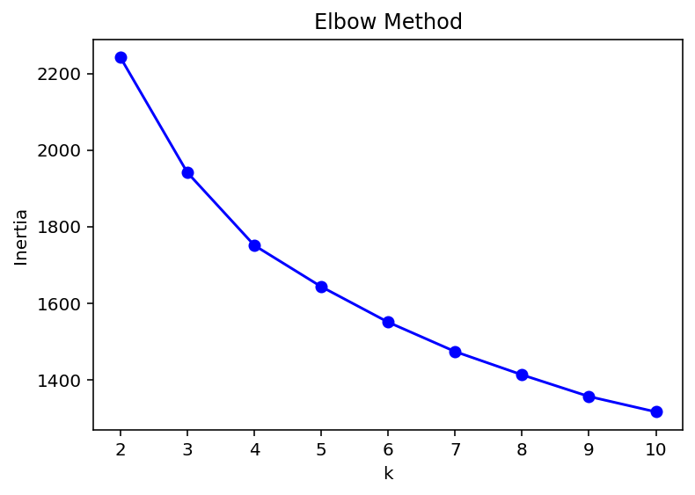
K-means clustering was performed on a dataset combining the importance scores from the Conjoint Analysis, the scores from the SEM constructs, and general clustering questions. The Elbow Method and Silhouette Analysis were used to determine the optimal number of clusters, with k=3 providing the most interpretable and well-segmented solution.

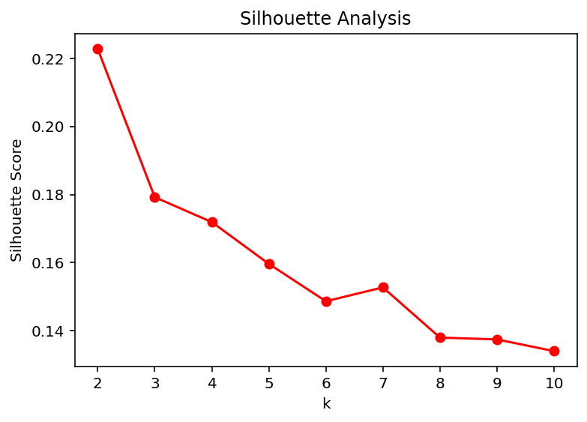
The resulting three-cluster structure was rigorously validated using one-way ANOVA. The results were significant across almost all input variables. The psychological constructs of INT (F=302.83, p<0.001), PBC (F=295.73, p<0.001), and SN (F=255.14, p<0.001) showed the most profound differentiation between clusters. Similarly, the Conjoint importance scores and clustering variables (clt1-clt7) also exhibited highly significant F-statistics (all p<0.01 except one). This confirms that the three clusters are statistically distinct and meaningful, representing unique consumer profiles that differ in their psychological drivers, deal attribute priorities, and general attitudes. The PCA-transformed plot of the clusters visualizes this clear separation, showing three distinct groupings with minimal overlap, thereby reinforcing the validity of the segmentation. The three clusters forming are as follows:

Cluster 0: The Balanced Pragmatists:
Consumers belonging to this cluster exhibit a moderate and practical approach to discount evaluation. They represent the mainstream consumers who appreciate savings but do not prioritize it above all else. This is the core market for standard promotional campaigns. They respond well to seasonal sales, bundle deals (e.g., "buy 2, get 20% off"), and straightforward percentage or cashback offers that provide clear, uncomplicated value.
Cluster 1: The Deal-Hunters:
These consumers are characterized by an extremely high responsiveness to promotions, indicating that discounts are their primary purchase driver. They are highly engaged, and active seekers of the best possible offers that they can get. They are likely to be influenced by perceptions of exclusive access and premium savings. Their high scores on value consciousness and perceived behavioural control suggest they are confident and motivated in their pursuit of deals. This cluster represents the most promotionally-active audience. Targeting them with VIP early access to sales, tiered loyalty discounts, and exclusive coupon codes will maximize engagement and sales volume from this highly receptive group.
Cluster 2: The Hard-to-Please Skeptics:
Customers in this cluster respond very poorly to conventional marketing strategies. Strong brand loyalty, non-promotional considerations, or a deep-seated skepticism about the true value of deals may influence their purchasing decisions. They need outstanding value offerings with low perceived risk. They may be influenced by strong subjective standards or particular viewpoints that go beyond discounting. Traditional discounts are ineffective and may even devalue your brand in their eyes. The key is to build trust and offer risk-free value. Strategies such as comprehensive cashback guarantees, free shipping with no minimum, extended trial periods, and leveraging social proof or influencer endorsements are essential to convert this high-value, loyal segment.
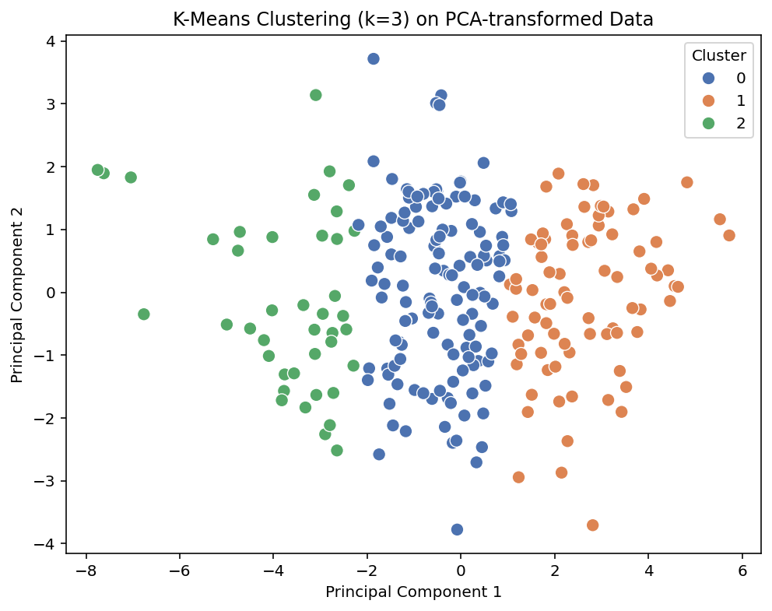
4.4 Logistic Regression: Predicting Purchase Behaviour
The final stage involved building a logistic regression model to predict actual purchase behaviour (BEH) using the cluster identities, SEM construct scores, and Conjoint importance scores as predictors.

 | precision | recall | f1-score | support
0 | 0.78 | 0.54 | 0.64 | 13
1 | 0.91 | 0.97 | 0.94 | 63
Accuracy |  |  | 0.89 | 76
Macro Avg | 0.84 | 0.75 | 0.79 | 76
Weighted Avg | 0.89 | 0.89 | 0.89 | 76
The model demonstrated strong predictive performance. It achieved an overall accuracy of 89.5% and an F1-score of 93.8% for the positive class (purchasers), indicating a good balance between precision and recall. The confusion matrix shows that the model is particularly adept at correctly identifying purchasers, with only 2 false negatives.
Analysis of the model coefficients reveals the key drivers of purchase behaviour. The most influential predictor was a specific variable from the clustering questions (`lr2`), followed by the psychological construct of Subjective Norms (SN). Other significant positive predictors included other clustering variables (`clt1`, `clt3`), Attitude (ATT), and Intention (INT). Interestingly, the Conjoint importance scores for "Minimum Spend" and "Expiry" had coefficients effectively equal to zero, suggesting that while these attributes determine deal preference, they are not direct predictors of final purchase behaviour once psychological and segment-level factors are accounted for. This is a crucial distinction, highlighting that what consumers say they prefer and what actually drives their action can be different.
From a marketer’s perspective, this research provides a cohesive framework to look beyond the traditional approach by studying in depth the psychological drivers and the consumer behaviour based on their discount preferences. The findings provide both tactical applications for coupon design and strategic depth for customer segmentation and conversion forecasting.
Marketers can frame optimal discounts by using Conjoint Analysis results, to design the foundational parameters of the offer, ensuring it captures maximum initial customer preference. From the analysis, we can infer that consumers evaluate the discounts holistically. Marketers must manage the top three important attributes-Minimum Spend (27.66%), Discount Type (26.92%), and Expiry (26.00%). A balance is important among these attributes as, for instance, an overly high Minimum Spend can negatively affect the utility of a discount coupon offered. Marketers should prioritize deep percentage discounts (e.g., "70% off," Utility: 1.707) over smaller percentages (e.g., "10% off," Utility: 0.485) to maximize subjective value and initial attraction.
The results of SEM and Logistic Regression together illustrate how the significant constructs of Theory of Planned Behaviour (TPB) influence the transition from customer interest to actual purchase conversion. For example, Perceived Behavioural Control (PBC) accounted for 19.41% importance in conjoint analysis and the Logistic Regression model identified Subjective Norms (SN) as one of the most influential predictors of purchase behaviour. Marketers should focus on making the redemption process user-friendly and leverage social proof strategies such as highlighting trending offers or peer participation—to enhance engagement and drive final purchase decisions.
K-means clustering moves the marketer beyond aggregate data analysis by creating distinct segments based on their psychological drivers. Based on the identified consumer segments, marketers can tailor communication and redemption methods that differ most significantly by Intention (INT), PBC, and Subjective Norms (SN). This segmentation avoids the limitations of relying on simple demographic data alone. This framework enables the marketer to recognize the critical distinction that, although Cluster Analysis defines the generic attractive parameters necessary to gain interest, Clustering and SEM define the specific psychological trigger (e.g., high Social Norm or high Perceived Behaviour Control) required to push that specific segment toward conversion. By using this framework, marketers can accurately forecast conversions and optimize resources by ensuring the right product is presented with the right TPB-based psychological message to the right customer group.
Practical Application:
The practical application of our integrated predictive model was conducted to evaluate its efficacy in a realistic business context. The logistic regression model, incorporating psychological constructs (ATT, SN, PBC, etc.), conjoint utilities, and cluster memberships, was used to forecast purchase probabilities for two e-commerce discounts: a Myntra-style offer (20% discount, ₹1000 minimum spend) and a Flipkart-style offer (₹300 flat discount, ₹1200 minimum spend). The results yielded a purchase probability of 9.3% for the Myntra offer and 10.2% for the Flipkart offer.
This marginal yet statistically significant difference reveals a critical insight: the flat discount (Flipkart) is marginally more effective despite its more restrictive conditions. This finding empirically validates our conjoint analysis, confirming that minimum spend (27.7% importance) can exert a slightly stronger influence on the final purchase decision than discount type (26.9% importance). However, the narrow 0.9 percentage-point difference underscores that no single discount strategy is universally superior. Instead, it powerfully reinforces the core conclusion of our research: optimal discounting requires a personalized, cluster-based approach, as contextual factors like brand perception and segment-specific preferences are decisive in maximizing conversion. The results achieved in this practical application can be backed by Zumstein, D., & Kotowski, W. (2020, April)

5. Summary and Conclusions
This project set out to segment consumers and predict their purchase behaviour based on discount deal preferences through an integrated analytical methodology. The approach successfully combined four distinct techniques: Conjoint Analysis to deconstruct preferences, SEM to model psychological drivers, Clustering for segmentation, and Logistic Regression for prediction.
The chosen integrated approach proved highly successful for several reasons. First, it moved beyond simplistic segmentation by blending stated preferences (Conjoint) with underlying psychological motivations (SEM) and general behavioural tendencies (clustering questions). This multi-faceted view resulted in rich, well-defined, and statistically robust consumer segments. Second, the sequential model building—from preference to psychology to segment to prediction—created a logical and comprehensive narrative of the consumer decision journey.
The success of the approach is evidenced by the strong statistical results at every stage: the high R-squared in the Conjoint model, the acceptable fit indices of the SEM model, the highly significant cluster differentiation in the ANOVA, and the high accuracy of the final predictive model.
A potential limitation, and an area where the approach might be less successful, lies in the measurement of actual behaviour. The low Cronbach's Alpha for the BEH construct suggests that capturing reliable behavioural data remains a challenge. In a future study, supplementing self-reported behaviour with observational or transactional data could strengthen this link. Furthermore, while the logistic regression model performs well, the dataset's class imbalance (more purchasers than non-purchasers) may slightly inflate performance metrics; techniques like SMOTE or stratified sampling could be explored to mitigate this.
In conclusion, this project demonstrates that an integrated analytical framework is not only feasible but also powerful. It provides actionable insights for marketers, allowing them to design targeted discount strategies for specific consumer segments and accurately forecast which customers are most likely to convert, thereby optimizing marketing resources and driving sales.
6. Bibliography
- Wang, C. H., & Wu, C. W. (2014). Combining conjoint analysis with Kano model to optimize product varieties of smart phones: A VIKOR perspective. Journal of Industrial and Production Engineering, 31(4), 177-186.
- Head, M., & Ziolkowski, N. (2012). Understanding student attitudes of mobile phone features: Rethinking adoption through conjoint, cluster and SEM analyses. Computers in Human Behaviour, 28(6), 2331-2339.
- Vrhovac, V., Orošnjak, M., Ristić, K., Sremčev, N., Jocanović, M., Spajić, J., & Brkljač, N. (2024). Unsupervised Modelling of E-Customers’ Profiles: Multiple Correspondence Analysis with Hierarchical Clustering of Principal Components and Machine Learning Classifiers. Mathematics, 12(23), 3794.
- Ufeli, C. P., Sattar, M. U., Hasan, R., & Mahmood, S. (2025). Enhancing Customer Segmentation Through Factor Analysis of Mixed Data (FAMD)-Based Approach Using K-Means and Hierarchical Clustering Algorithms. Information, 16(6), 441.
- Paetz, F., Hein, M., Kurz, P., & Steiner, W. J. (2019). Latent class conjoint choice models: A guide for model selection, estimation, validation, and interpretation of results. Marketing ZFP 41: 3–20.
- De Bruyn, A., Liechty, J. C., Huizingh, E. K., & Lilien, G. L. (2008). Offering online recommendations with minimum customer input through conjoint-based decision aids. Marketing Science, 27(3), 443-460.
- John, J. M., Shobayo, O., & Ogunleye, B. (2023). An exploration of clustering algorithms for customer segmentation in the UK retail market. Analytics, 2(4), 809-823.
- Sentosa, I., & Mat, N. K. N. (2012). Examining a theory of planned behaviour (TPB) and technology acceptance model (TAM) in internet purchasing using structural equation modelling. Researchers World, 3(2 Part 2), 62.
- Zumstein, D., & Kotowski, W. (2020, April). Success factors of e-commerce-drivers of the conversion rate and basket value. In 18th International Conference e-Society 2020 (pp. 43-50).
- Chakraborty, G., & Cole, C. (1991). Coupon characteristics and brand choice. Psychology & Marketing, 8(3), 145-159.
- Langen, H., & Huber, M. (2023). How causal machine learning can leverage marketing strategies: Assessing and improving the performance of a coupon campaign. Plos one, 18(1), e0278937.
7. Appendix:
Method | Initial Column | Renamed Column
Conjoint Analysis | Scenario 1  - Discount Type: 20% off  - Minimum Spend: ₹1,000  - Expiry: Expires in 24 Hours  - Redemption: Code at Checkout | C1
 | Scenario 2  - Discount Type: ₹500 Flat Off  - Minimum Spend: ₹2,000  - Expiry: Valid for 7 Days  - Redemption: Automatic at Checkout | C2
 | Scenario 3  - Discount Type: Buy 1 Get 1 Free (BOGO)  - Minimum Spend: None  - Expiry: Valid Today Only  - Redemption: Automatic on Cart | C3
 | Scenario 4  - Discount Type: 15% Cashback  - Minimum Spend: ₹500  - Expiry: Valid for 3 Days  - Redemption: Credited to Wallet | C4
 | Scenario 5  - Discount Type: Free Shipping  - Minimum Spend: ₹500  - Expiry: Valid for 14 Days  - Redemption: Automatic at Checkout | C5
 | Scenario 6  - Discount Type: 30% Off  - Minimum Spend: ₹3,000  - Expiry: Valid Today Only  - Redemption: Code at Checkout | C6
 | Scenario 7  - Discount Type: ₹200 Cashback  - Minimum Spend: ₹1,500  - Expiry: Valid for 5 Days  - Redemption: Wallet Credit | C7
 | Scenario 8  - Discount Type: 25% Off  - Minimum Spend: ₹0 (No minimum)  - Expiry: Expires Tonight  - Redemption: Automatic at Checkout | C8
 | STRUCTURAL EQUATION MODEL
Impulsiveness | - I often make purchases spontaneously without much planning.  - Discounts and coupons often tempt me to buy things I hadn’t planned to.  - I regret impulsive purchases after using a discount. | Impulse 1  Impulse 2  Impulse 3
FOMO | - If I don’t use a discount before it expires, I feel like I missed a great deal.  - Limited-time coupons push me to purchase faster.  - I often compare my discounts with friends/family to ensure I’m not missing out. | Fomo 1  Fomo 2  Fomo 3
Value Consciousness | - I carefully evaluate discounts to see if they truly give me value.  - I prefer coupons that give guaranteed savings over uncertain rewards.  - A higher discount percentage always feels more attractive to me. | Vc1  Vc2  Vc3
Trust | - I trust that companies give genuine discounts and not inflated prices.  - I feel secure using online coupons from reputed brands.  - I prefer discounts that are simple and transparent. | t1  t2  t3
ATT | - Using discounts/coupons when I shop is a good idea.  - Getting a discount makes the shopping experience more enjoyable.  - Using discounts is beneficial for my finances.  - Using discounts is a smart way to shop.  - Using discounts/coupons is usually a hassle. | a1  a2  a3  a4  a5
SN | People who are important to me think I should use discounts/coupons.  My friends/family often encourage me to use discounts.  Most people in my social circle use coupons for shopping.  I feel social pressure to take advantage of discount offers. | sn1  sn2  sn3  sn4
PBC | I find it easy to locate and use valid discounts/coupons.  I know how to apply coupons/promotions while shopping online or in-store.  Using discounts requires little effort for me.  Problems like expired codes or complicated check out prevent me from using discounts. | Pb1  Pb2  Pb3  Pb4
BINT | - I intend to use discounts/coupons the next time I shop.  - I plan to search for discount codes before making purchases.  - I will try to use available discount offers in the coming month. | Bint1  Bint2  Bint3
Actual Behaviour | - In the past month, how often did you use a discount or coupon when making purchases? (Never / 1–2 times / 3–5 times / 6–10 times / 11+ times) — (ordinal)  - Approximately what proportion of your purchases last month used some discount? (0–25% / 26–50% / 51–75% / 76–100%) — (ordinal)  - When offered a discount at checkout, I usually redeem it. (7-point agreement scale) | Beh1  Beh2  Beh3
Psychographic Profiling | Shopping is a way for me to reward myself. | clt1
 | I often buy things because they make me feel good, not because I need them. | clt2
 | I like being the first among my peers to try new offers. | clt3
 | I enjoy talking about discounts I got with others | clt4
 | I feel guilty if I miss out on a good deal. | clt5
 | I prefer quality over discounts, even if it costs more. | clt6
 | I enjoy comparing products and prices before making a decision. | clt7
Logistic Regression | Would you buy now with this offer? | lr2
 | How likely are you to purchase now with this offer? | lr3
 | How satisfied are you with this offer? | lr4
 | I clearly understood the offer shown above. | lr5
 | Which redemption method was shown?  (Auto Applied/Manually chosen/Enter Code) | lr6
Form Link: Survey Link

